Classification of Quest in Video Adventure Games
: focused on Uncharted 3_Drake's Deception

YeonJi Ju, Mijin Kim

Department of Visual Contents, Division of Digital Contents
Graduate School of Dongseo University, Dongseo University
Busan, South Korea
Ju90511@gmail.com, mjkim@dongseo.ac.kr

Abstract

Video adventure game is a game genre in which scenario-based minor or major episodes are expressed by game level and several experiences are provided to a player. Episodes can be divided by quest unit and player’s behaviors can differ by quest. The present verbs used in each MMORPG quest to classify the quests of video adventure game, and reclassify. With the results as base, this study collected player’s behaviors found in a video adventure game by verb unit, examined the distribution, and mapped them to certain quests. This method can be an efficient method to help intuitively know the quest structure of a story-based video adventure game intuitively.

Keywords-Video Adventure Game; Quest; Player Behavior;

I. Introduction

Video adventure game is a game genre where players perform various quests (traveling, attacking and collecting) under the theme of In a game, quest means a small mission a player has to fulfil in relation with a story [1]. A quest is designed in the form of action and puzzle and placed to a certain location in game space [2]. A game developer sets experience that he or she wants to give players in the form of ‘verb’ and the verbs become means of expressing the quest in detail [3]. Therefore, the collected data of player’s behaviors that are expressed in verb form are those necessary to classify quests intuitively. Especially, they can help compose and design game levels to play based on story, which is an important feature of adventure game genre.
Game players interact with game levels with the actions taken while playing a game [4]. For this reason, gameplay behavior analysis is much helpful in understanding the relations with quests or the components in a game space to attract certain actions in game. In other words, knowing how a game is accepted to a player can help find problems and improvements to make at the stage of game development and maintenance and repair.
To classify the quests of video adventure game, the present study grouped 200 similar verbs by MMORPG quest and sorted them to 26 representative verbs. With this, it collected the verbs used in ‘The Dreamers of the Day’, which is the 22nd episode of ‘Uncharted 3: Drake's Deception' that is one of the most popular video adventure games, examined the distribution of verbs by quest, and classified them into 7 quests upon them.

II. The Verve used in Quest

A quest is a small unit of a mission that players fulfill to get diverse experience and grow within an episode. Depending on a method a player uses to perform and complete a quest, this study divided quests 7 types (combat, dialogue, collection, travel, action, search, and others) in MMORPG game genre and listed the verbs used in each quest [3]. However, those verbs are for MMORPG game, and thus may not be appropriate for games in other genres. Upon 200 verbs used in MMORPG game, this study grouped them by similarity so that they can be suitable for a video adventure game and data of gameplay behaviors can be easily collected. Table 1 shows 26 verbs derived from the groping.
TABLE I
QUEST TYPE AND VERVE IN VIDEO ADVENTURE GAME

Quest Type | Verve
Combat | Kill, Destroy, Escort, Defense
Dialogue | Talk, Visit, Convey, Report
Collection | Glean, Gain, Get, Retrieve
Action | Use, Operate, Decipher, Rescue
Search | Irradiate, Find, Scout
Travel | Move, Take away, Return, Escape
Other | Buy, Help, Learn

III. Classification of Quests: Case Study
‘Uncharted 3_Drake's Deception’

Video adventure game is a passive game genre where gameplay behaviors are manifested based on a scenario set by a game developer. Therefore, quests and components of game space that are designed and assigned Based on Table 1, this study analyzed gameplay behaviors found in ‘The Dreamers of the Day’, which is the 22nd episode of ‘Uncharted 3: Drake's Deception (published in 2011)’. In this episode, a main character gets to a certain location and investigates into a commissioned task according to time order. Each quest could be matched with the verbs in Table 1 and Table 2 shows the order of gameplay.
TABLE Ⅱ
MATCHING QUEST TYPE AND VERVE IN EPISODE ‘THE DREAMERS OF THE DAY’

Quest No. | Verve | Quest Type
1 | Move(5), Kill(3) | Travel
2 | Use(1), Move(2), Kill(12) | Combat
3 | Talk(4) | Dialogue
4 | Rescue(1), Talk(2),Operate(3) | Action
5 | Kill(19), Talk(1), Escort(4) | Combat
6 | Talk(1), Glean(2) | Collection
7 | Talk(2), Opearate(1) | Dialogue
8 | Irradiate(2), Rescue(1) | Search
9 | Help(2), Rescue(1) | Other
10 | Talk(1), Escort(1), Destroy(2) | Combat
11 | Operate(1), Escort(1), Kill(2) | Combat
12 | Use(3), Move(2), Kill(2) | Action
13 | Talk(2), Escape(9) | Travel
14 | Kill(1), Talk(4), Escape(1) | Dialogue

A player performs each of 14 different quests in sequence that comprises a relevant episode. Player’s behaviors that take place while performing each quest are expressed in verb unit and the distribution of the verbs are studied to classify them to certain quests. As seen in Table 2, 7 types of quests take place from once to 4 times in the relevant episode: (Travel: twice, Combat: 4 times, Dialogue: 3 times, Action: twice, Collection: once, Search: once, and others: once). When looking into the contents of each quest, it is known that it has a certain mission as seen in Figure 1: (① to operate a structure in the shape of an elevator, ② to travel over steps using a ladder or stairs, ③ to collect objects necessary to progress a game, ④ to collect weapons related to a combat, ⑤ to go into a combat, and ⑥ to talk with NPC to acquire information necessary to continue an episode)
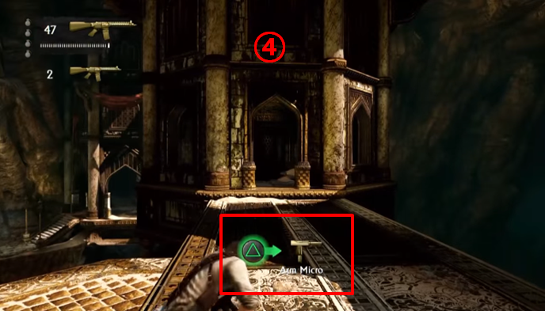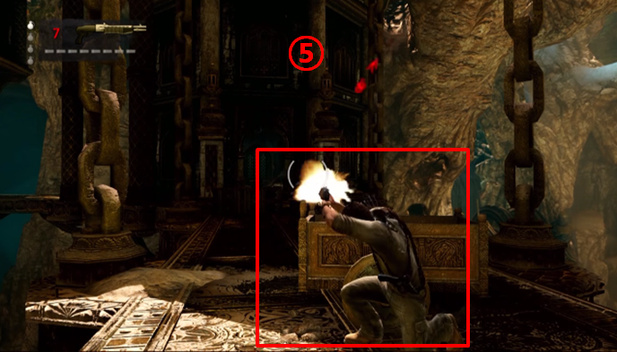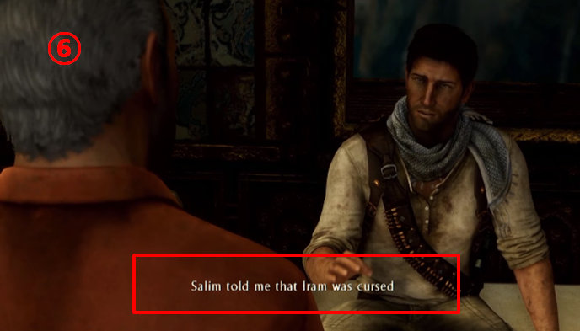
Fig. 1 Quest in Episode 'The Dreamer of the Day'

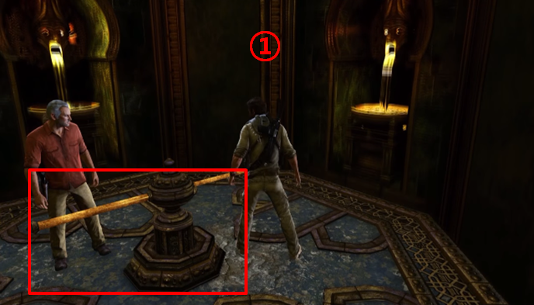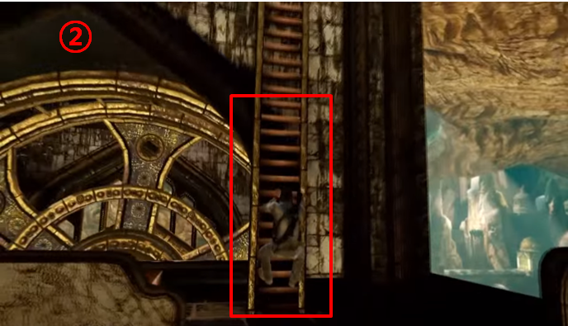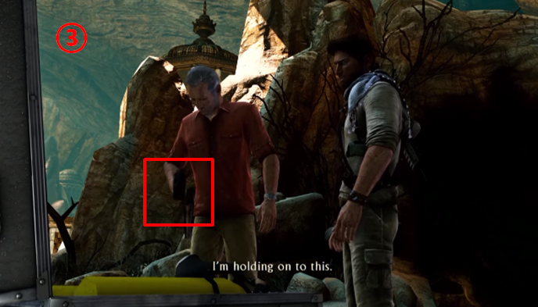
The linking structure of this quest induces a player to behave along with a quest on the basis of the overall story of a video
adventure game and so it is easy for a developer to control the flow of gameplay as intended. Therefore, collecting player’s behaviors in verb unit is an efficient method that helps understand the types of quests intuitively and the overall story of a video adventure game.

V. Conclusion

The present study proposed collection of player’s behaviors in verb unit in order to classify the quests of a video adventure game. Referring to the classification of verbs used in MMORPG, this study grouped similar verbs to representative verb and reclassified them to fit a video adventure game. With this, this study mapped the verbs used in a certain episode with quests in one of the popular video adventure games. As a result, it will help understand the story flow of a video adventure game intuitively, and can be basic data in setting game levels to which a quest is applied. In a following study, the author will extend analysis subjects and intends to propose the main structure of a video adventure game.

References

[1] I. Lee, “The Effect of Puzzle System on Player’s level of Immersion and Engagement in Adventure Games”, Journal of Korea Game Society, Vol. 8, No. 4, pp.17-27, 2008.
- J. Choi, “The differences of player experience according to intention formation method in adventure Game”, Master’s thesis, KAIST, 2015.
- M. Kang, “A Design Proposal on Analysis of Quest in MMORPGs: -Focused on World of Warcraft-”, Master’s thesis, Sangmyung University, 2013.
- C. Ryu, H. Yun, “Storytelling theory in virtual world”, A study about digital storytelling, Vol. 3, No. 1, 2008.

